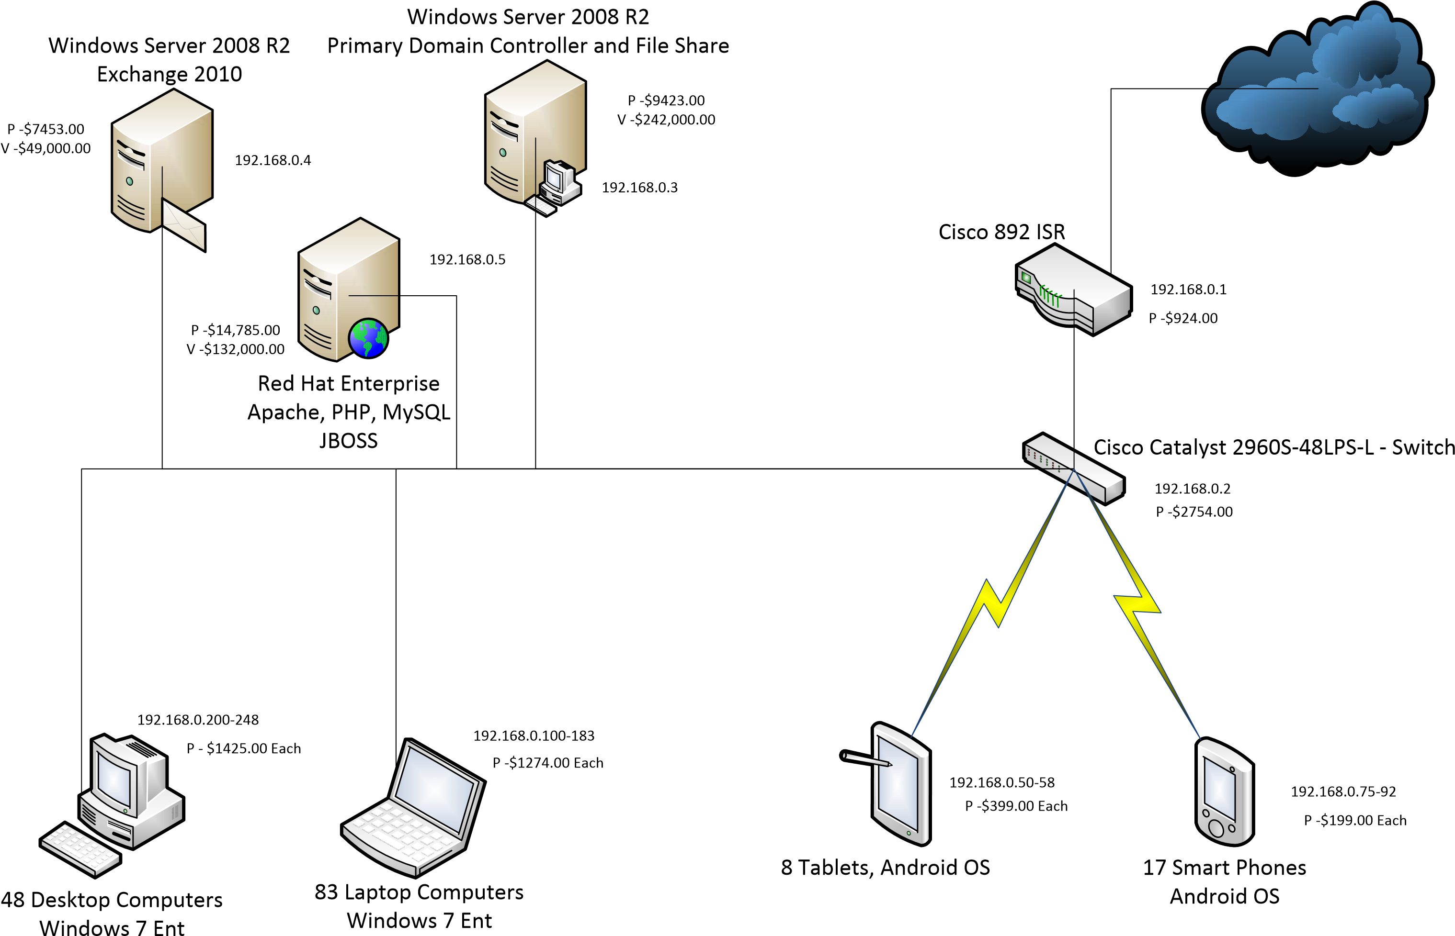

U05A1 – Directions – For this assignment, evaluate the above network diagram for a basic small marketing firm in San Francisco, CA. You have been asked to writeup a basic risk assessment for this company. In the first part, brainstorm and list every risk you can imagine (realistic for this company) include virtual, physical and “stupid” in your listing. Provide a brief one-to-two sentence overview for each risk you list. In the second section, pick the top risk and create a Quantitative RA (last module) for a single loss expectancy. Each event will have it’s own price tag and amount of downtime. The values for each device is listed as “P” for physical cost and “V” for the estimated value of the data on each device. Each day the network is down results in a loss of $86,000.00.

Risks:

Tornado destroys the building.

Earthquake shakes the building too hard.

Brute force attack on the network.

A worker clicked a link to a virus from their email.

Server got unplugged.

Coffee was spilt on the server or on a computer.

Pack of bulls mistake the company for a fine china shop.

Server overheats due to California temperature.

Microsoft decides to privatize Windows, and no one is allowed to use it but them.

Another company sends in spies as interns.

Aliens steal the company.

Database gets deleted by new boss.

Ex-employee replaces all saved data with thousands of memes.

Bees decide to move into the server.

The cloud gets deleted.

Nerf war gets too intense.

California is on fire again.

The firewall somehow catches fire.

Power outage causes trouble.

Thief steals a bunch of computers.

Risk Analysis: **Tornado destroys the building.**

The tornado levels the building destroying everything in its wake.

Completely destroyed building and everything inside unsalvageable gives 100% exposure factor.

|  |  |  |  |  |
| --- | --- | --- | --- | --- |
| Items | Price Physical | Price Virtual | Exposure Factor | SLE |
| Cisco 892 ISR | $924.00 | 0 | 100% | $924.00 |
| Cisco Catalyst 2960S-48-LPS-L-Switch | $2754.00 | 0 | 100% | $2754 |
| 17 Smart Phones | $3400 | 0 | 100% | $3400 |
| 8 Tablets | $3200 | 0 | 100% | $3200 |
| 83 Laptop Computers | $105742 | 0 | 100% | $105742 |
| 48 Desktop Computers | $68400 | 0 | 100% | $68400 |
| Window Server 2008 R2 Exchange 2010 | $7453 | $49000 | 100% | $56453 |
| Window Server 2008 R2 Primary Domain | $9423 | $242000 | 100% | $251423 |
| Red Hat Enterprise | $14785 | $132000 | 100% | $146785 |
| Network cost 1095 days | 0 | $94,170,000 | 100% | $94,170,000 |
| 40 Floor Construction Cost | $140000000 | 0 | 100% | $140000000 |
| Total | $140216081.00 | $94,593,000.00 | 100% | $234,809,081.00 |

To build a skyscraper in California the average time it takes is 2-4 years so we will use 3 as they already have the previous building plan but must spend time removing the old building wreck and working out the foundation. If the network does not become up and running until the building is complete, then we have 1095 days it is not running. I am unable to find a time that workers can enter before construction is finished so for safety the company will not start until the construction completes. $86000 for each day down. The average floor count I am using is 40 floors and 3.5 million per floor.

$94,170,000 network cost while construction is underway.

References:

*Rebuilding after a natural disaster - experts weigh in*. Mycorporation. (2019, May 14). Retrieved October 2, 2022, from https://blog.mycorporation.com/2017/11/rebuilding-after-a-natural-disaster-experts-weigh-in/

*Rebuilding stronger and faster after natural disasters: HUD USER*. Rebuilding Stronger and Faster After Natural Disasters | HUD USER. (n.d.). Retrieved October 2, 2022, from https://www.huduser.gov/portal/pdredge/pdr-edge-featd-article-111819.html

*Storm shelters & tornado shelters in the US*. Ground Zero Storm Shelters. (n.d.). Retrieved October 2, 2022, from https://www.groundzeroshelters.com/california-tornado-averages

Team, C. H. (2022, May 25). *How much does it cost to build a skyscraper?* CostHack.com. Retrieved October 2, 2022, from https://costhack.com/cost-to-build-a-skyscraper/#:~:text=to%20%241Billion.-,Skyscrapers%20can%20range%20significantly%20in%20price%20from%20%24150%20Million%20to,and%20purpose%20of%20your%20skyscraper.

Wikimedia Foundation. (2022, September 30). *List of tallest buildings in San Francisco*. Wikipedia. Retrieved October 2, 2022, from https://en.wikipedia.org/wiki/List_of_tallest_buildings_in_San_Francisco#Timeline_of_tallest_buildings

Wikimedia Foundation. (2022, September 30). *Millennium Tower (San Francisco)*. Wikipedia. Retrieved October 2, 2022, from https://en.wikipedia.org/wiki/Millennium_Tower_(San_Francisco)#Sinking_and_tilting_problem